**MINI PROJECT-I**

**(2020-21)**

**IOT based smart gate**

**SYNOPSIS**



**Institute of Engineering & Technology**

## **Sparsh Agrawal**

**(18150072)**

## Submitted to

**Mr. Amir khan**

**Technical Trainer**

**Department of Computer Engineering & Applications**

**INDEX**

➢ **INTRODUCTION**

➢ **OBJECTIVE OF THE PROJECT**

➢ **METHODOLOGY**

➢ **SOFTWARE TO BE USED**

➢ **HARDWARE TO BE USED**

➢ **FUTURE SCOPE**

➢ **CONCLUSION**

**INTRODUCTION:-**

**At the time of covid-19, as we all know how this affect our life it changes our life styles we carry sanitizers everywhere because of the fear of corona instead of this some people are kept by corona.Because mainly we touch gates at banks,homes,shops,etc.**

**At those places we want gate keepers for safety they also become patient of corona.**

**With the use of this type of gate specially gate keepers are protected from corona.With the use of temperature sensor they can check the body temperature.**

**EXISTING SYSTEM:-**

**At that time we have this machine but this is it upgraded version it have spray machine to spray sanitizer and with security measurments.**

**OBJECTIVE OF THE PROJECT:-**

The main objective is to protect our family members and other people from corona virus.

**Functionality provided by this gate:-**

**• It can check the whole body.**

**• It shows the details of that person who passes from this gate like body temperature,pulse,thermal vision of the body.**

**• It shows the detail of that person.**

**METHODOLOGY:-**

**When any person passes through this machine check the body pulse rate,temperature,alcohol.**

**This happen when it applies at public space.**

**When it apply at home in this we have face recognition sensor,eye sensor.**

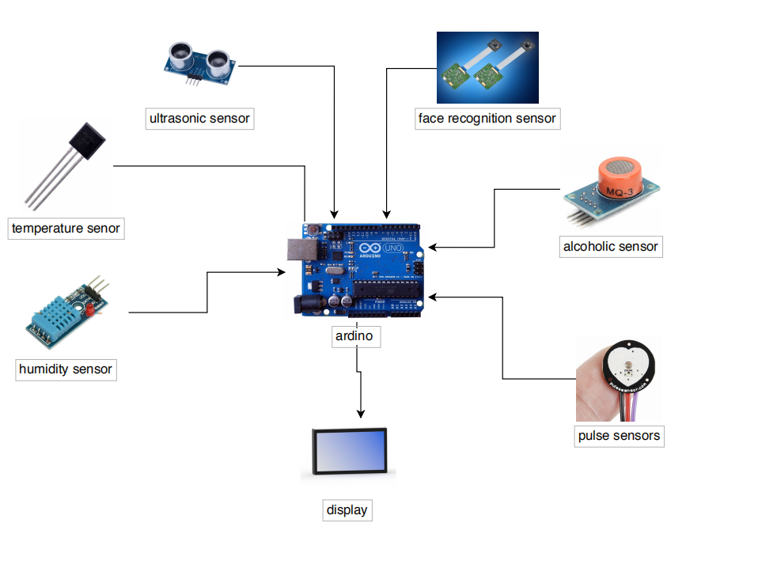

**SOFTWARE REQUIRMENTS:-**

• Windows 7 or Higher

• Any operating systems

**HARDWARE REQUIRMENTS:-**

• Humidity sensor

• Temperature sensor

• Pulse sensor

• Ultra sonic sensor

Etc.

**Future Scope:**

• We can use it in many places like hotels,restaurants,malls,banks,etc.

• It can save many people from corona.

• It reduces labour.

**CONCULSION:-**

**At the end of this project, we will get a fully functional smart gate.**

**WEBSITE REFERENCE:-**

[www.google.com](http://www.google.com)